Product Inventory Management System
Ideation Phase
Empathize & Discover

Date | 07/03/2026
Team ID | SWTID-2026-6317
Project Name | Product inventory management
Maximum Marks | 4 Marks

Empathy Map Canvas:
An Empathy Map is a visual tool used to understand a user’s thoughts, feelings, behaviors, and experiences. It helps teams gain deeper insights into what users say, think, do, and feel while interacting with a system. By analyzing these aspects, teams can better understand the user’s needs, goals, and challenges. This process encourages teams to look at the problem from the user’s perspective. It also helps identify the difficulties and frustrations users may face in real-life situations. Empathy mapping improves communication among team members and keeps the focus on user-centered design. It helps in identifying opportunities for improving the product. As a result, teams can develop solutions that are more efficient, practical, and user-friendly.

Example:
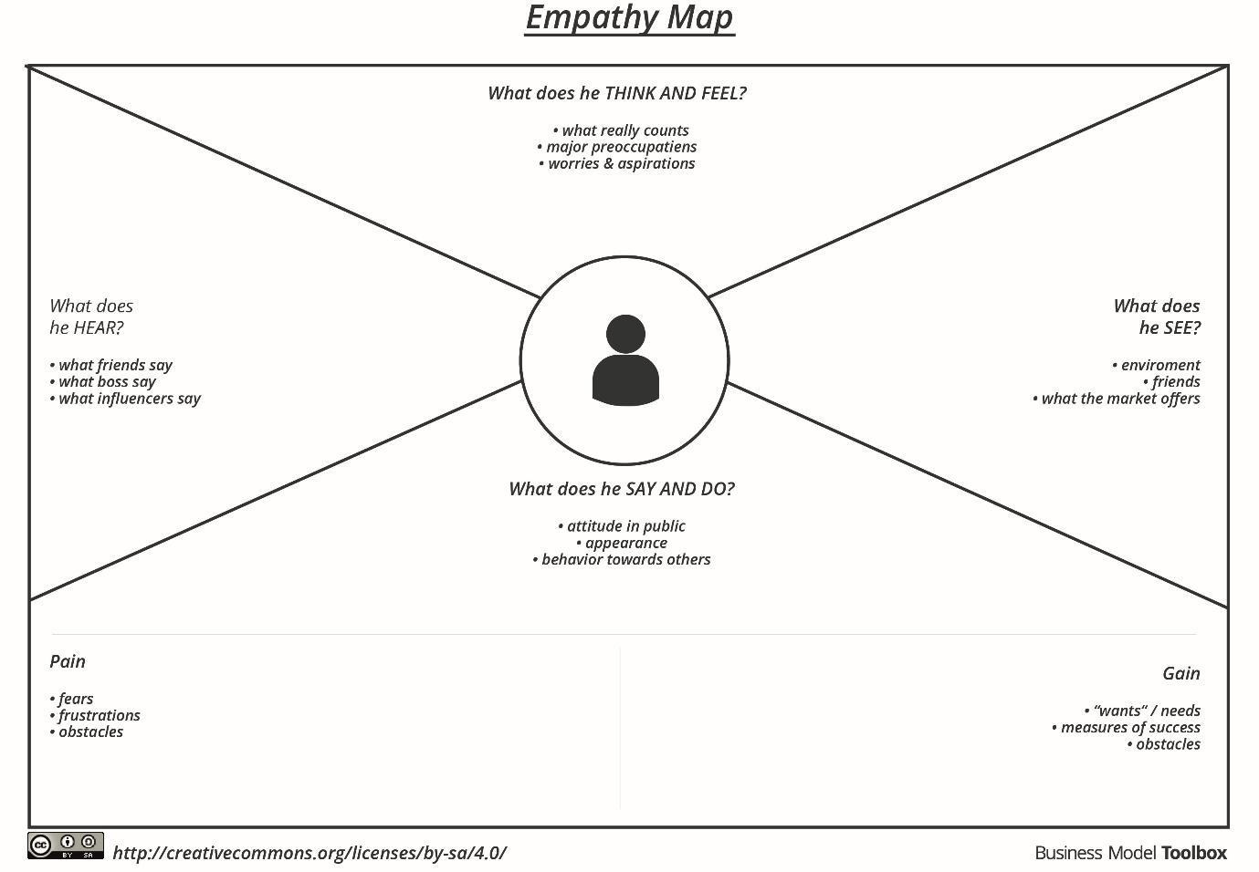

Reference: https://www.mural.co/templates/empathy-map-canvas

